**Canteen Menu**

**Introduction to the project:**

|  |  |
| --- | --- |
| Imagine that you are assigned to a new project as a tester.  Testing team: you and test team lead Mike.  This is a small mobile project for iOS.  “Canteen menu” application is developed for a huge company located all over the world. Application is targeted on company’s canteens stuff. It will be used for week menu management (creation, edition, etc).  Canteen employees are equipped with iPads or iPhones X.  After login to the application user (canteen employee) is redirected to “Menu List” screen with the list of menus for different company’s canteens (in different locations), “Country”, “City”, “Canteen” filters.  **New feature “Menu Editor” will be implemented during the upcoming iteration.**  Your task is:   1. Review the requirements for the new feature provided by BA Barbara 2. In case of any questions you have to write email to Barbara with request to clarify your questions 3. Provide estimations for test activities for this feature by email to your test lead Mike 4. Write test cases for the feature 5. Review provided screens with the implemented feature 6. Find and submit bugs in case of any 7. Send test results and your decision about quality of the feature to Mike (\*optional)   **Below you will find requirements for the feature and templates for emails, test cases, bug reports, etc. Please fill in only those templates that you think reasonable in scope of this feature. You can write any additional information if required.** | E:\lectures\Test 3\1.png |
| **Requirements for the new feature:**  AS an administrator  I CAN **create menu**:   1. I am in “Menu List” screen 2. I click “create” button - “Menu Editor” screen opens 3. I type canteen name in “Menu name” field 4. I choose canteen from list and click it 5. I select “To” date from date picker 6. I select “From” date from date picker 7. I click “save” button – “Menu List” screen opens, new menu is added to the list | E:\lectures\Test 3\2crop.png |
| AS an administrator  I CAN **edit menu**:   1. I am in “Menu List” screen 2. I click edit icon C:\Users\Lidziya_Smirnova\Desktop\Icons\89031-200.png - “Menu Editor” screen opens 3. From the dates panel I choose date I want to add dish offers to 4. In dish categories list I choose category I want to add dish offers to 5. If there are no dishes in the category – empty field is displayed 6. If the number of dishes exceeds the screen – the list can be scrolled 7. I can remove dish from the list 8. “Add dish” feature will be implemented later | |
| E:\lectures\Test 3\2.png | E:\lectures\Test 3\2a.png |

**Clarification letter to BA regarding new feature:**

|  |  |
| --- | --- |
| **To:** | Barbara Smith |
| **CC:** | Mike |
| **Subject:** | List of questions about the new feature |
| Dear Barbara,  Send you a list of questions about the new feature:  1. What kind of iPads can the canteen staff be equipped with?  2. Which versions of iOS should be supported?  3. On the screen “Menu List” in the filters “Country”, “City”, “Canteen” can be searched by entering values from keyboard or only by using the dropdown menu? If yes, which characters are supported?  4. What languages are supported by the application?  5. If the menu list on screen “Menu List” fills the whole screen, what is the reaction of the app?  6. What is the maximum number of menus lists on screen “Menu List” can be displayed?  7. What are the validation criteria for entering in field of “Menu Name” on “Canteen Menu” screen?  8. On the screen “Canteen Menu” in the filter “Canteen X” can be searched by entering values from keyboard or only by using the dropdown menu? If yes, which characters are supported?  9. What is the function of the Lupa button on the screen “Canteen Menu”?  10. What is the maximum and minimum date range that can be selected in the “From/To” fields?  11. How will dates be displayed in the maximum time slot and the minimum time slot?  12. What application response to date entry “To” more than “From”?  13. If the canteen has dish categories other than “Soup”, “Main dish”, “Dessert”, for example “Drink” how to add them?  14. Does the app support screen rotation?  15. What type of mobile app? Native, hybrid, web?  15. Is an internet connection required for the app to work? If so, how many active users are supported?  16. What is the expected app's behavior when the internet connection is lost?  17. How is the “Country”, “City” selected in the menu creation for canteen?  18. What date format?  19. How exactly the menu is deleted?  Thank you for your answers!  --  Regards,  Daria Pavlovskaya  Cell: +375295533552  Email: [dasha212112@gmail.com](mailto:dasha212112@gmail.com) | |

**Test estimations for new feature to Test team lead:**

|  |  |
| --- | --- |
| **To:** | Mike |
| **CC:** |  |
| **Subject:** | Test estimations for new feature |
| Dear Mike,  Send you Test estimations for new feature:  **Test estimations**  **Prepared by:** Daria Pavlovskaya  **Role:** Tester  **Date of preparation:** 20.02.2023   * Review of documentation 50 min * Communication 10 min * Creation of test documentation 40 min * Passing tests 20 min * Bugs Reporting 30 min * Test result report 20 min     Thank you for your time!  --  Regards,  Daria Pavlovskya  Cell: +375295533552  Email: [dasha212112@gmail.com](mailto:dasha212112@gmail.com) | |

**Test cases for new feature:**

|  |  |  |  |  |  |  |  |  |  |
| --- | --- | --- | --- | --- | --- | --- | --- | --- | --- |
| **ID** | **Priority** | **Module** | **Title** | **Precondition** | **Description** | **Steps** | **Expected result** | **Status**  **Passed/Failed** | **Comments** |
| 1 | smoke | Create menu | Menu creation | Must be in filters on Canteen Menu screen: Canteen: Canteen X; Location: Belarus;  City: Minsk; | Empty menu creation for canteen 1 | 1. Click on “Create” on Canteen Menu screen  2. Type canteen name in “Menu name” field: Menu canteen  3. Choose canteen from list and click it: Canteen X  4. select “To” date from date picker: 7 August 2017  5. select “From” date from date picker: 11 August 2017  6. click “save” button | 1. “Menu Editor” screen opens  5. number of date fields displayed 5 and with information on days of the week and dates  6. “Menu List” screen opens, “Menu canteen” menu is added to the list of menu |  |  |
| 2 | smoke | edit menu | Menu edition | Must be in filters on Canteen Menu screen: Canteen: Canteen X; Location: Belarus;  City: Minsk;  Must be created menu:  1. Click on “Create” on Canteen Menu  2. Type canteen name in “Menu name” field: Menu can  3. Choose canteen from list and click it: Canteen X  4. select “To” date from date picker: 17 August 2017  5. select “From” date from date picker: 21 August 2017  6. click “save” button | Edit Name of Menu | 1. Open menu “Menu can”  2. Rename menu to “Menu 6”  3. Click Save | 1. Menu editor of “Menu can” is opened  3. “Menu canteen” rename to “Menu 6” |  |  |
| 3 | critical | Delete menu | Menu deletion from “Menu List” | Must be in filters on Canteen Menu screen: Canteen: Canteen X; Location: Belarus;  City: Minsk;  Must be created menu:  1. Click on “Create” on Canteen Menu  2. Type canteen name in “Menu name” field: Menu 6  3. Choose canteen from list and click it: Canteen X  4. select “To” date from date picker: 10 August 2017  5. select “From” date from date picker: 14 August 2017  6. click “save” button | Menu deleting from “Menu List” | 1. Delete menu from screen “Menu List” | 1. “Menu 6” is deleted from Menu List |  |  |
| 4 | **critical** | **Create menu** | **Create menu in Russian language** | Must be in filters on Canteen Menu screen: Canteen: Canteen X; Location: Belarus;  City: Minsk; | **Create menu in Russian language** | 1. Click on “Create” on Canteen Menu screen  2. Type canteen name in “Menu name” field: Меню для всех  3. Choose canteen from list and click it: Canteen X  4. select “To” date from date picker: 7 August 2017  5. select “From” date from date picker: 11 August 2017  6. click “save” button | 1. “Menu Editor” screen opens  5. number of date fields displayed 5 and with information on days of the week and dates  6. “Menu List” screen opens, “Меню для всех” menu is added to the list of menu |  |  |
| **5** | **Critical** |  | **Data after closing the app** |  | **Exit the app with data, stop it through the switcher of app and open app again.**  Must be in filters on Canteen Menu screen: Canteen: Canteen X; Location: Belarus;  City: Minsk;  Must be created menu:  1. Click on “Create” on Canteen Menu  2. Type canteen name in “Menu name” field: Menu 6  3. Choose canteen from list and click it: Canteen X  4. select “To” date from date picker: 10 August 2017  5. select “From” date from date picker: 14 August 2017  6. click “save” button | **1. Exit from app**  **2. Open app switcher and swipe from bottom to top “Canteen menu” app**  **3. Open app again** | **3.** “Menu List” screen opens, “Menu 6” is displayed |  |  |
|  |  |  |  |  |  |  |  |  |  |
|  |  |  |  |  |  |  |  |  |  |
|  |  |  |  |  |  |  |  |  |  |
|  |  |  |  |  |  |  |  |  |  |
|  |  |  |  |  |  |  |  |  |  |

**“Menu Editor” feature is ready for testing:**

Developers have finished implementation of “Menu Editor” feature. Build with the feature is released and successfully installed.

When editing the menu you see the following screen:

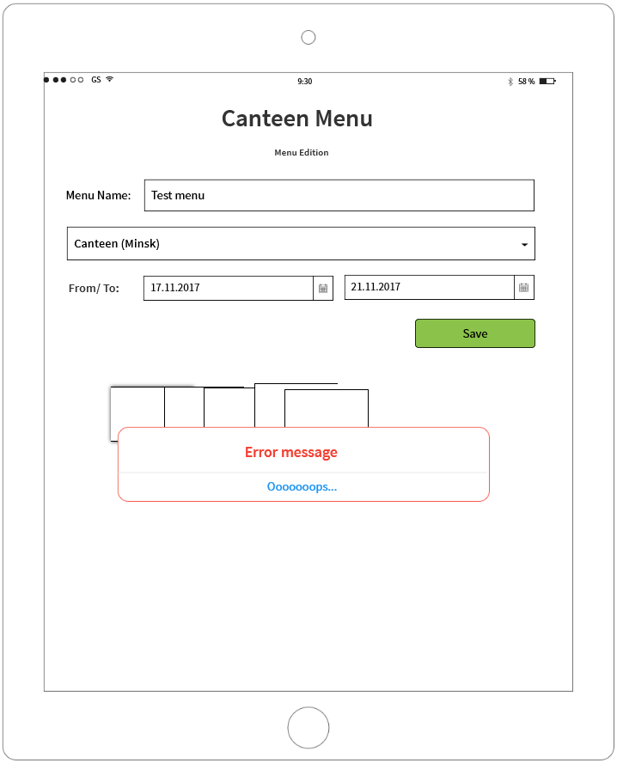

**If you see any bugs in this screen, you can post them below:**

**Bug reports:**

|  |  |
| --- | --- |
| **Bug ID** | **#1** |
| **Summary** | Date display windows overlap in Menu Editor when selecting range of date |
| **Precondition** | Must be in filters on Canteen Menu screen: Canteen: Canteen X; Location: Belarus;  City: Minsk;  Must be created menu:  1. Click on “Create” on Canteen Menu  2. Type canteen name in “Menu name” field: Menu can  3. Choose canteen from list and click it: Canteen X  4. select “To” date from date picker: 17 August 2017  5. select “From” date from date picker: 18 August 2017  6. click “save” button  Expected result:  6. “Menu List” screen opens, “Menu canteen” menu is added to the list of menus |
| **Description** | Date display windows overlap in Menu Editor when selecting range of date from 17.11.2017 to 21.11.2017 |
| **Priority** | ASAP |
| **Severity** | critical |
| **Steps to reproduce** | * + - 1. Click on Edit menu “Menu can”       2. Change date “To”: 21.08.2017 |
| **Expected result:** | 2. Date is changed to “21.08.2017” and displayed 5 separate windows |
| **Actual result:** | 2. Date display windows overlap and empty error |
| **Attachment** |  |
| **Bug ID** | **#2** |
| **Summary** | Empty date data in Menu Editor when selecting range of date |
| **Precondition** | Must be in filters on Canteen Menu screen: Canteen: Canteen X; Location: Belarus;  City: Minsk;  Must be created menu:  1. Click on “Create” on Canteen Menu  2. Type canteen name in “Menu name” field: Menu can  3. Choose canteen from list and click it: Canteen X  4. select “To” date from date picker: 17 August 2017  5. select “From” date from date picker: 18 August 2017  6. click “save” button  Expected result:  6. “Menu List” screen opens, “Menu canteen” menu is added to the list of menus |
| **Description** | Empty date data in Menu Editor when selecting range of date |
| **Priority** | high |
| **Severity** | critical |
| **Steps to reproduce** | * + - 1. Click on Edit menu “Menu can”       2. Change date “To”: 21.08.2017 |
| **Expected result:** | 2. Date is changed to “21.08.2017” and data of dates is displayed |
| **Actual result** | 2. data of dates is empty |
| **Bug ID** | **#3** |
| **Summary** | Error in the name of the edit tab “Menu Edition” |
| **Precondition** | Must be in filters on Canteen Menu screen: Canteen: Canteen X; Location: Belarus;  City: Minsk;  Must be created menu:  1. Click on “Create” on Canteen Menu  2. Type canteen name in “Menu name” field: Menu can  3. Choose canteen from list and click it: Canteen X  4. select “To” date from date picker: 17 August 2017  5. select “From” date from date picker: 18 August 2017  6. click “save” button  Expected result:  6. “Menu List” screen opens, “Menu canteen” menu is added to the list of menus |
| **Description** | Error in the name of the edit tab “Menu Edition” |
| **Priority** | low |
| **Severity** | major |
| **Steps to reproduce** | * + - 1. Click on Edit menu “Menu can” |
| **Expected result** | Tab is named “Menu Editor” |
| **Actual result** | Tab is named “Menu Edition” |

**Test result report to Test team lead:**

|  |  |
| --- | --- |
| **To:** | Mike |
| **CC:** |  |
| **Subject:** | Test Result Report of new feature |
| Dear Mike,  Send you Test Result Report of new feature.  **Test result report**  **Canteen Menu**  **20.02.2023**  **Test team:**   |  |  |  | | --- | --- | --- | | **Name** | **Position** | **Role in the project** | | **Daria Pavlovskaya** | **Tester** | **Functional testing** |     **Testing process description:**  **Test environment:** OC Windows 11 build 20208.  **Test level:** Component testing**.**  **Test types used:** Functional, GUI, Localization.  All test scenarios were created based on requirements from doc for Control work using black-box techniques.  **Summary:**  **Test Analysis:** There are 4 bugs found.  **Testing timetable:**   |  |  |  |  | | --- | --- | --- | --- | | **Tester** | **Date** | **Description** | **Duration** | | Daria Pavlovskaya | 20.02.2023 | Review of documentation; Communication; Creation of test documentation; Passing tests; Bugs Reporting; Test result report; | 3h |     **Recommendations:**  **I would recommend to focus on corrections for critical functionality first for new feature. I don't recommend releasing it.**      **New bugs found:**   |  |  |  | | --- | --- | --- | | **1** | **Critical** | Date display windows overlap in Menu Editor when selecting range of date | | **2** | **critical** | Empty date data in Menu Editor when selecting range of date | | **3** | **major** | Error in the name of the edit tab “Menu Edition” |     **All bugs statistics:**   |  |  |  |  |  |  | | --- | --- | --- | --- | --- | --- | | Status | Quantity | Severity | | | | | Critical | Major | Medium | Minor | | New | 3 | 2 | 1 | 0 | 0 |   --  Regards,  Daria Pavlovskya  Cell: +375295533552  Email: [dasha212112@gmail.com](mailto:dasha212112@gmail.com) | |